# Statistical Inference: Peer Graded Assignment

Author: Brynjólfur Gauti Jónsson

# Summary

The purpose of this assignment is to compare theoretical parameters of the Exponential Distribution to empirically obtained measurements sampled via simulation. The Exponential Distribution samples a continuous Poisson process.

## Sampling the Distribution

We will sample the distribution in R using rexp(n, lambda) where lambda is the rate. We will sample 40 exponentials a 1000 times and store the mean of each of the samples.

set.seed(101)  
exp <- NULL  
for (i in 1:1000) exp <- c(exp, mean(rexp(40, 0.2)))  
head(exp)

## [1] 4.034012 4.994885 3.809412 4.670817 5.168187 5.396491

Now that we have obtained a sample of exponentials we can go ahead with our calculations.

# 1. The Mean

The theoretical mean of the Exponential Distribution is calculated such:

$μ=1/λ$.

Let's compare that to the mean of our distribution of means.

# Empiric Mean  
mean(exp)

## [1] 5.012603

# Theoretical Mean  
1/0.2

## [1] 5

# Difference in Means  
abs(mean(exp)-1/0.2)

## [1] 0.01260258

We aproximated the theoretical mean very closely.

# 2. The Variancee

The theoretical variance is derived by:

$σ^{2}=\frac{1}{(λ*\sqrt{n})^{2}}$.

Now we compare it to an empirically obtained variance.

# Empirical Variance  
var(exp)

## [1] 0.5985383

# Theoretical Variance  
(0.2 * sqrt(40))^-2

## [1] 0.625

# Difference in Variances  
abs(var(exp) - (0.2 * sqrt(40))^-2)

## [1] 0.02646167

# 3. Normality of Means

We plot a histogram with an overlaid density curve to get a view of the normality.

library(ggplot2)   
library(ggthemes)  
g <- ggplot(data.frame(x = exp), aes(x=x)) + theme_tufte()  
  
g + geom_histogram(aes(y = ..density..), fill = 'royalblue2', color='black',  
 alpha = 0.7, binwidth = .1) +   
 stat_function(fun = 'dnorm', args=list(mean=1/0.2, sd = (0.2 * sqrt(40))^-2)) +  
 xlab('Mean') + ylab('Density') + ggtitle('Density and Histogram Plot')

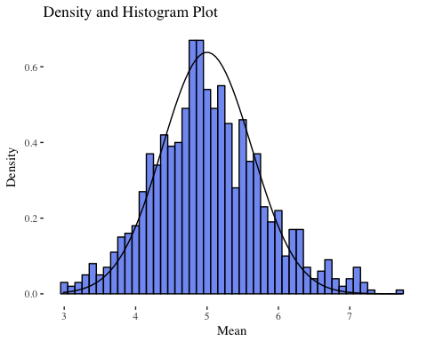

We assumed in this assignment that a large enough sample of means gathered from a large enough sample of exponentials would be approximately normally distributed. We have shown that to be so.